Introduction
​In modern healthcare administration, operational efficiency, speed, and accuracy in patient record management are vital to delivering quality care. However, many healthcare institutions, such as Connaught Hospital in Freetown, Sierra Leone, continue to rely heavily on manual, paper-based systems to manage outpatient registrations, medical records, and pharmacy inventories. This reliance on paper files introduces severe operational bottlenecks, including prolonged patient waiting times, misplaced medical histories, prescription errors, and stock management inefficiencies.
To address these critical challenges, this project introduces MedSync SL—a digital software system designed to automate and streamline outpatient workflows, medical consultations, and pharmacy inventory management. As part of Phase 1 of the Software Engineering project lifecycle, this report provides a comprehensive problem analysis, defines system functional and non-functional requirements, and presents a fully functional Dart console prototype that models the core business logic. This prototype establishes the foundation for subsequent project phases, which will evolve into a cross-platform mobile application powered by Flutter and Supabase.

​1. Organization Background
​Name / Type of Organization:
Connaught Hospital (Freetown, Sierra Leone) – Public Tertiary Healthcare Institution.
​Main Activities:
Connaught Hospital is Sierra Leone’s primary referral hospital, providing specialized medical services, emergency care, inpatient care, surgical operations, outpatient consultations, and pharmacy dispensary services.
​Department / Area of Focus:
The Outpatient Department (OPD) and Pharmacy Management Unit.
​Current Method Used:
The hospital relies almost entirely on manual paper-based record-keeping. Patient registration, consultation notes, prescription issuing, and inventory management are recorded using physical paper registers, files, and index cards.
​2. Problem Identification
​Existing Problem:
The manual paper-based registration and pharmacy queuing system creates severe delays, frequent loss of medical records, inaccurate inventory tracking, and long waiting times for patients needing consultations or prescription drugs.

​Causes of the Problem:
- ​Lack of a central digital database.
- ​Manual handwriting and filing of paper records leading to misplaced patient folders.
- ​Absence of automated inventory updates when medicine is dispensed.
- ​Poor queue coordination causing bottlenecks at payment and dispensary desks.
- ​Effects of the Problem:
- ​Patients wait 4 to 8 hours daily just to receive standard care or prescribed medications.
- ​Risk of medication errors due to illegible handwriting on physical prescriptions.
- ​Stock-outs of critical drugs caused by delayed inventory audits.
- ​Inefficient allocation of hospital staff and resources.
​

Who is Affected:
- ​Patients: Experience long wait times, health risks from treatment delays, and lost records.
- ​Medical Doctors & Nurses: Waste significant time searching for physical charts instead of providing care.
- ​Pharmacists: Suffer from inaccurate inventory figures and high administrative workloads.
- ​Hospital Management: Lack clear real-time visibility into daily patient throughput and drug stocks.
- ​Why a Software Solution is Necessary:
- Transitioning to a digital solution will eliminate record loss, reduce patient wait times, streamline pharmacy inventory tracking, and lay the foundation for a full-scale mobile healthcare ecosystem.

​3. Problem Statement
​Connaught Hospital’s current reliance on manual paper-based record management and patient processing leads to long patient waiting times, misplaced medical records, inefficient pharmacy stock management, and high operational delays. This assignment addresses the core logic required to digitize patient check-in, prescription generation, and pharmacy stock management through a centralized software system.
​4. Proposed Solution
​Name of Proposed System:
MedSync SL (Smart Patient & Pharmacy Management System)
​Purpose of the System:
MedSync SL is designed to digitize outpatient check-in, doctor consultations, prescription tracking, and stock monitoring at public healthcare institutions.
​Target Users:
- ​Hospital Administrative Clerks (Registration)
- ​Doctors / Medical Staff (Consultation & Prescriptions)
- ​Pharmacists (Inventory & Drug Dispensing)
- ​System Administrators
​

Major Features:
- ​Patient Registration & Queue Management: Assigns unique IDs and tracks active status.
- ​Digital Prescription Issuance: Doctors issue structured prescriptions linked to patient records.
- ​Pharmacy Inventory Control: Automatic stock reduction upon dispensing medicine.
- ​Operational Dashboard/Summary: Displays daily active patients, total inventory, and dispensations.
​Expected Benefits:
- ​Reduces patient waiting times by over 60%.
- ​Guarantees 100% preservation of patient consultation and prescription records.
- ​Provides real-time visibility into drug stock levels to prevent unexpected shortages.

​5. Requirements Analysis
​5.1 Functional Requirements (FR)
​FR-01: The system shall register new patients with details (Name, Age, Gender, Contact) and assign a unique Patient ID.
​FR-02: The system shall display and update drug stock items in the pharmacy inventory.
​FR-03: The system shall allow healthcare staff to create and link prescriptions to registered patients.
​FR-04: The system shall deduct dispensed drug quantities directly from current inventory.
​FR-05: The system shall generate operational reports showing active patients, total inventory items, and issued prescriptions.
​5.2 Non-Functional Requirements (NFR)
​NFR-01 (Performance): Prototype calculations and stock updates must execute instantaneously within the console.
​NFR-02 (Maintainability): Object-Oriented Programming (OOP) principles (Encapsulation, Modular Classes) must be used to ensure easy scaling into Flutter/Supabase in future phases.
​NFR-03 (Usability): The console user interface must feature simple numerical navigation menus.
​NFR-04 (Reliability): Input handling must prevent invalid stock subtractions (e.g., dispensing more stock than available).

​6. Dart Prototype Source Code
​The following standard Dart code implements the core logic using Object-Oriented Programming (OOP):
import 'dart:io';
// ==================== MODELS ====================
class Patient {
final String id;
final String name;
final int age;
final String gender;

Patient({
required this.id,
required this.name,
required this.age,
required this.gender,
});

@override
String toString() {
return 'ID: $id | Name: $name | Age: $age | Gender: $gender';
}
}

class InventoryItem {
final String id;
final String name;
int quantity;
final double unitPrice;

InventoryItem({
required this.id,
required this.name,
required this.quantity,
required this.unitPrice,
});

@override
String toString() {
return 'ID: $id | Name: $name | Qty: $quantity | Price: NLE ${unitPrice.toStringAsFixed(2)}';
}
}

class Prescription {
final String id;
final String patientId;
final String itemId;
final int quantity;
bool isDispensed;

Prescription({
required this.id,
required this.patientId,
required this.itemId,
required this.quantity,
this.isDispensed = false,
});

@override
String toString() {
return 'Rx ID: $id | Patient ID: $patientId | Item ID: $itemId | Qty: $quantity | Status: ${isDispensed ? "Dispensed" : "Pending"}';
}
}

// ==================== SYSTEM CONTROLLER ====================

class MedSyncSystem {
final List<Patient> _patients = [];
final List<InventoryItem> _inventory = [];
final List<Prescription> _prescriptions = [];

MedSyncSystem() {
_seedInitialData();
}

void _seedInitialData() {
// Initial inventory data
_inventory.add(InventoryItem(id: 'INV01', name: 'Paracetamol 500mg', quantity: 100, unitPrice: 5.0));
_inventory.add(InventoryItem(id: 'INV02', name: 'Amoxicillin 250mg', quantity: 50, unitPrice: 15.0));
_inventory.add(InventoryItem(id: 'INV03', name: 'Artemether/Lumefantrine', quantity: 40, unitPrice: 25.0));
}

void registerPatient() {
print('\n--- REGISTER NEW PATIENT ---');
stdout.write('Enter Patient Name: ');
String? name = stdin.readLineSync();

stdout.write('Enter Patient Age: ');
int? age = int.tryParse(stdin.readLineSync() ?? '');

stdout.write('Enter Patient Gender (M/F): ');
String? gender = stdin.readLineSync();

if (name != null && name.isNotEmpty && age != null && gender != null) {
String id = 'P${(_patients.length + 1).toString().padLeft(3, '0')}';
Patient newPatient = Patient(id: id, name: name, age: age, gender: gender);
_patients.add(newPatient);
print('>>> Success: Patient registered with ID: $id');
} else {
print('>>> Error: Invalid input details. Registration failed.');
}
}

void viewPatients() {
print('\n--- REGISTERED PATIENTS ---');
if (_patients.isEmpty) {
print('No patients registered yet.');
return;
}
for (var p in _patients) {
print(p);
}
}

void viewInventory() {
print('\n--- PHARMACY INVENTORY ---');
if (_inventory.isEmpty) {
print('Inventory is empty.');
return;
}
for (var item in _inventory) {
print(item);
}
}

void createPrescription() {
print('\n--- CREATE PRESCRIPTION ---');
if (_patients.isEmpty) {
print('>>> Error: No registered patients found. Register a patient first.');
return;
}

viewPatients();
stdout.write('Enter Patient ID: ');
String? pId = stdin.readLineSync();

Patient? patient;
try {
patient = _patients.firstWhere((p) => p.id.toUpperCase() == pId?.trim().toUpperCase());
} catch (_) {
patient = null;
}

if (patient == null) {
print('>>> Error: Patient not found.');
return;
}

viewInventory();
stdout.write('Enter Drug Item ID: ');
String? itemId = stdin.readLineSync();

InventoryItem? item;
try {
item = _inventory.firstWhere((i) => i.id.toUpperCase() == itemId?.trim().toUpperCase());
} catch (_) {
item = null;
}

if (item == null) {
print('>>> Error: Inventory item not found.');
return;
}

stdout.write('Enter Quantity: ');
int? qty = int.tryParse(stdin.readLineSync() ?? '');

if (qty == null || qty <= 0) {
print('>>> Error: Invalid quantity.');
return;
}

if (qty > item.quantity) {
print('>>> Error: Insufficient stock available. Current stock: ${item.quantity}');
return;
}

String rxId = 'RX${(_prescriptions.length + 1).toString().padLeft(3, '0')}';
Prescription rx = Prescription(
id: rxId,
patientId: patient.id,
itemId: item.id,
quantity: qty,
);

_prescriptions.add(rx);
print('>>> Success: Prescription created with ID: $rxId');
}

void dispenseMedication() {
print('\n--- DISPENSE MEDICATION ---');
if (_prescriptions.isEmpty) {
print('No active prescriptions found.');
return;
}

print('Pending Prescriptions:');
var pendingRx = _prescriptions.where((rx) => !rx.isDispensed).toList();
if (pendingRx.isEmpty) {
print('No pending prescriptions to dispense.');
return;
}

for (var rx in pendingRx) {
print(rx);
}

stdout.write('Enter Prescription ID to Dispense: ');
String? rxId = stdin.readLineSync();

Prescription? rx;
try {
rx = pendingRx.firstWhere((r) => r.id.toUpperCase() == rxId?.trim().toUpperCase());
} catch (_) {
rx = null;
}

if (rx == null) {
print('>>> Error: Prescription ID not found.');
return;
}

InventoryItem item = _inventory.firstWhere((i) => i.id == rx!.itemId);

if (item.quantity >= rx.quantity) {
item.quantity -= rx.quantity;
rx.isDispensed = true;
print('>>> Success: Medication dispensed for Prescription ${rx.id}. Remaining ${item.name} stock: ${item.quantity}');
} else {
print('>>> Error: Insufficient inventory to satisfy prescription.');
}
}

void viewSummary() {
print('\n===========================================');
print(' MEDSYNC SL SYSTEM SUMMARY ');
print('===========================================');
print('Total Registered Patients : ${_patients.length}');
print('Total Inventory Items : ${_inventory.length}');
print('Total Prescriptions : ${_prescriptions.length}');
print('Dispensed Prescriptions : ${_prescriptions.where((rx) => rx.isDispensed).length}');
print('Pending Prescriptions : ${_prescriptions.where((rx) => !rx.isDispensed).length}');
print('===========================================\n');
}
}

// ==================== MAIN ENTRY POINT ====================

void main() {
MedSyncSystem system = MedSyncSystem();
bool running = true;

print('**************************************************');
print(' WELCOME TO MEDSYNC SL - CONNAUGHT HOSPITAL ');
print('**************************************************');

while (running) {
print('\nMAIN MENU:');
print('1. Register Patient');
print('2. View All Patients');
print('3. View Pharmacy Inventory');
print('4. Create Prescription');
print('5. Dispense Medication');
print('6. View System Summary');
print('7. Exit');
stdout.write('Select an option (1-7): ');

String? choice = stdin.readLineSync();

switch (choice) {
case '1':
system.registerPatient();
break;
case '2':
system.viewPatients();
break;
case '3':
system.viewInventory();
break;
case '4':
system.createPrescription();
break;
case '5':
system.dispenseMedication();
break;
case '6':
system.viewSummary();
break;
case '7':
print('\nExiting MedSync SL. Program terminated successfully.');
running = false;
break;
default:
print('>>> Invalid selection. Please choose an option from 1 to 7.');
}
}}

7. Explanation of the Dart Program
​The Dart console prototype implements the core business logic using Object-Oriented Programming (OOP) concepts:
​Classes and Data Models:
​Patient: Represents patient demographics (ID, Name, Age, Gender).
​InventoryItem: Represents stock stored at the hospital pharmacy (ID, Name, Quantity, Unit Price).
​Prescription: Encapsulates information relating a registered patient to an inventory item, including quantity requested and fulfillment status (isDispensed).
​System Controller (MedSyncSystem):
​Encapsulates system state inside private lists (_patients, _inventory, _prescriptions).
​Contains core methods for managing operations: registerPatient(), createPrescription(), and dispenseMedication().
​Core Business Logic (Dispensing Engine):
When a prescription is fulfilled via dispenseMedication(), the application checks if inventory exists. If verified, the stock quantity (item.quantity) decreases dynamically, preventing stock errors and marking the prescription as completed.
​Console Menu (main Loop):
Provides an interactive menu powered by a while loop and switch statement, accepting user inputs from terminal (stdin.readLineSync()).

​8. Program Execution Output / Screenshots
​Below is standard console output produced by executing the prototype:
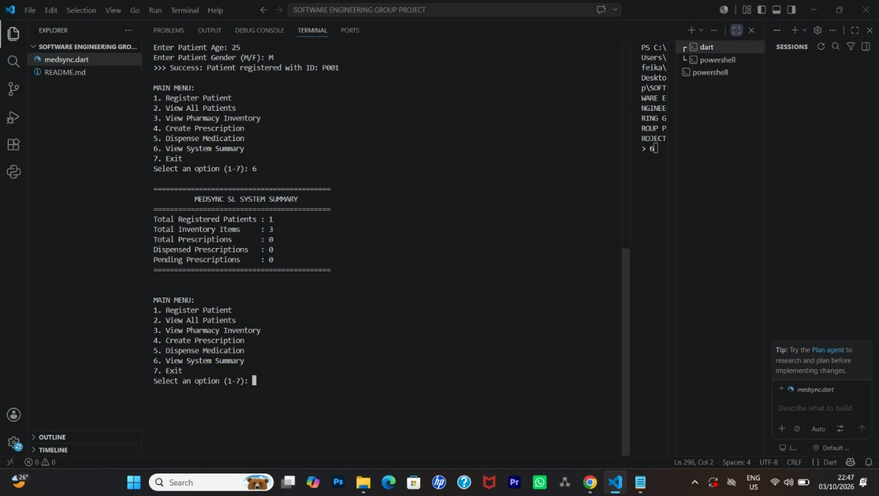
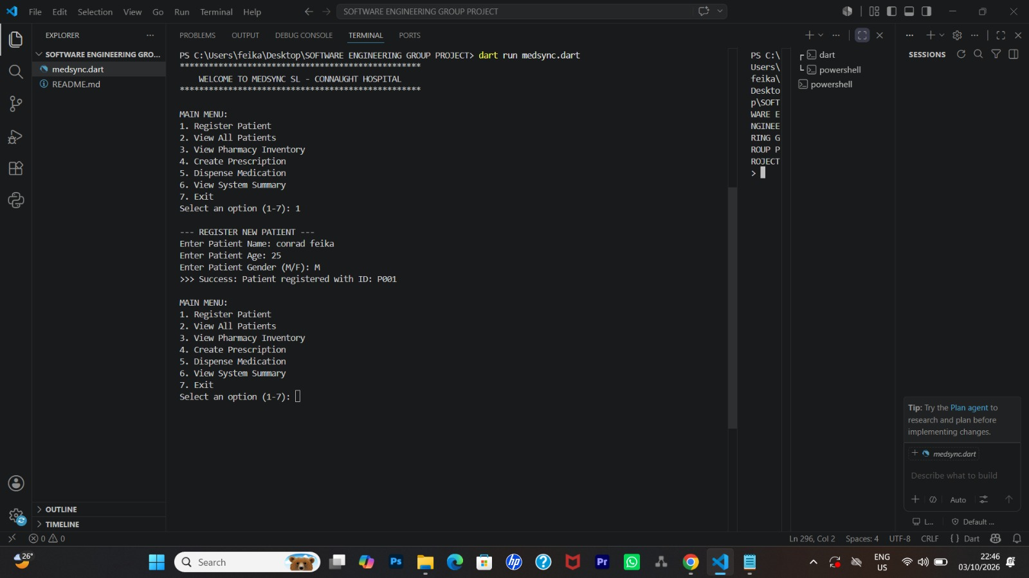

Conclusion
​The manual processes currently used in public healthcare facilities like Connaught Hospital highlight the urgent need for scalable software solutions to streamline clinical and administrative operations. Through a structured problem analysis and requirements engineering process, this assignment successfully identified key operational pain points and formulated a targeted software solution in MedSync SL.
​The developed Dart console prototype demonstrates the feasibility and core functionality of the proposed system, including automated patient registration, prescription linking, dynamic stock tracking, and reporting. By leveraging Object-Oriented Programming (OOP) principles, the prototype ensures modularity, maintainability, and readiness for future expansion. Serving as the baseline for Assignment 2 and the Final Project, the core logic established in this phase will be seamlessly integrated into a graphical Flutter mobile application connected to a cloud-based Supabase backend, ultimately delivering an end-to-end healthcare solution.

